**BIGBASKET**

**Online Grocery Store**

**About Big basket:**

Big basket is an online food and grocery store. Here you will find everything you are looking for. Right from fresh Fruits and Vegetables, Rice and Dals, Spices and Seasonings to Packaged products, Beverages, Personal care products, Meats . You can pay online using your debit / credit card or by cash on delivery. We guarantee on time delivery, and the best quality!

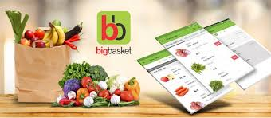

**Navigation bar (on top):**

* Company name
* Avatar button (login/create account)
* Shop by category
* Search bar
* Location selection
* Cart

**Advertisements and offers banners section:**

* A division where advertisements and offers move in a floating window.

**Menu bar:**

* My smart basket :

A division below banner section where different categories of items are available to see.

**Filters:**

* Sort by price
* User rating
* Price ranges
* Popular brands
* Discount

**Item list:**

* Each item in separate division.
* Image of item and name
* Option to buy and add to cart
* Increase the quantity of item
* User rating
* Discount offers if available

**Payment gateway:**

Always floating icon of cart on bottom right corner so user can easily go to cart.

**Site Outlook :**

